**1990s Grand Baroque Mirror**

**Price: $785**

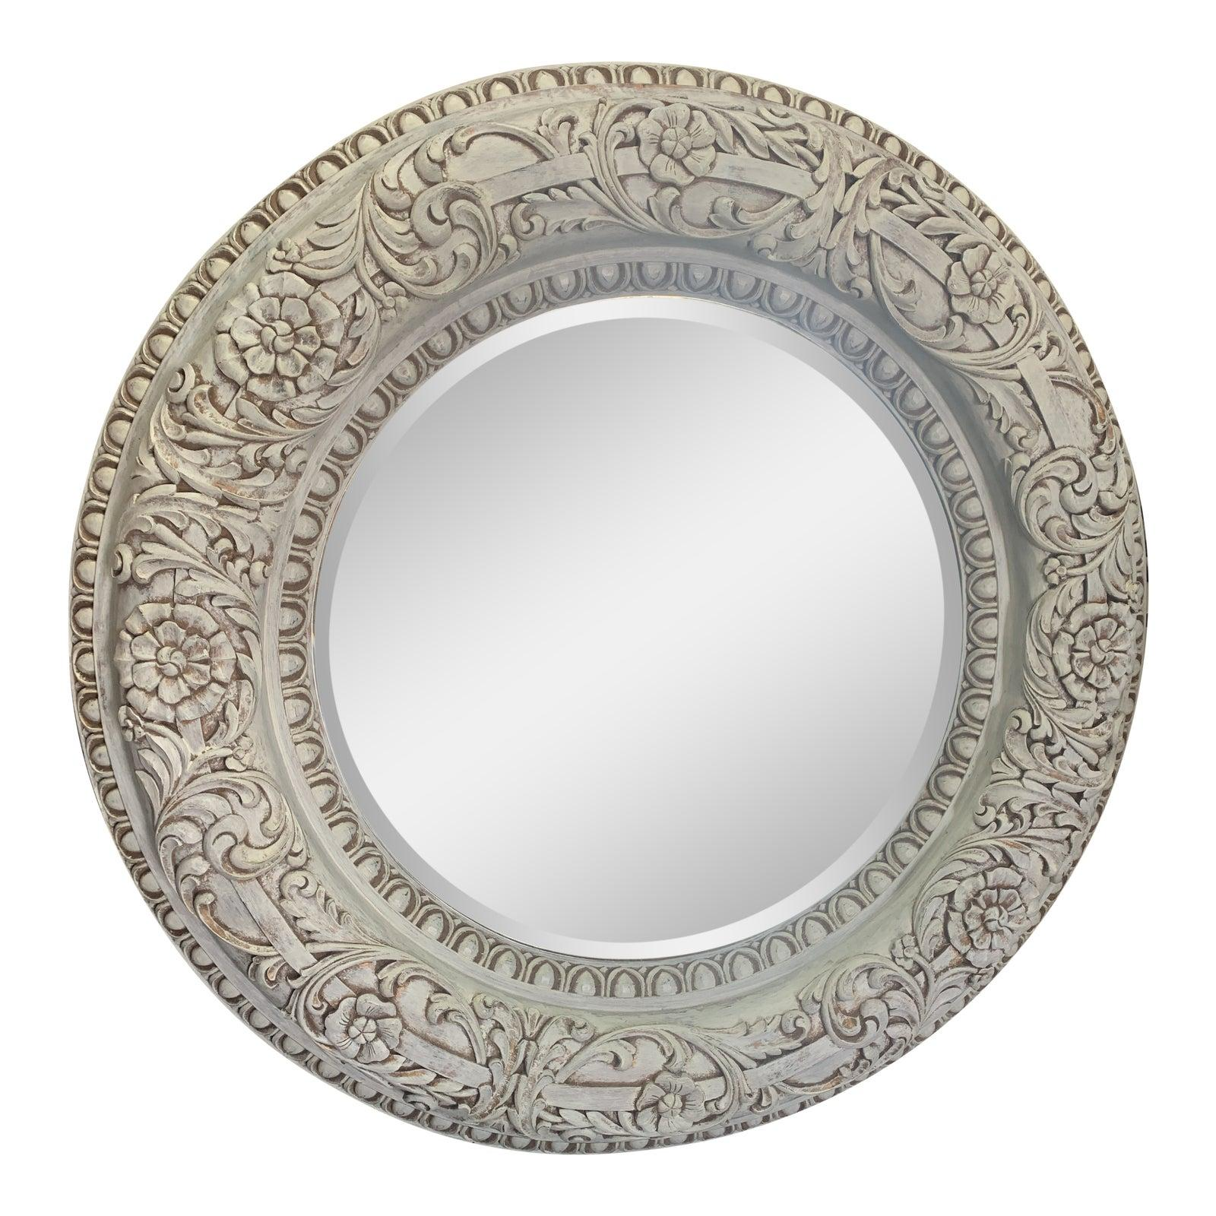

* CATEGORIES

Bedroom Mirrors

* MATERIALS

LED Mirrors

* SHAPE

Circle

* BRAND

Citybuilding